$1,500.00
Children’s Dance Theater
PERFORMING ARTS SCHOLARSHIP For graduating students planning to attend college in the fall of 2024 and achieve a major or minor in the performing arts. (dance, music or theater)
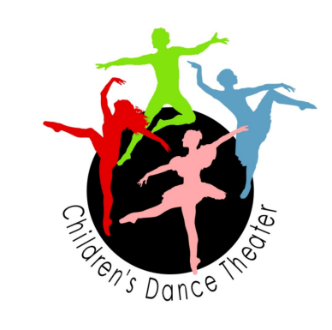
Please include the following with your application:
An essay stating your goals in the performing arts and why you are interested in the performing arts. Two (2) letters of recommendation. (non family members)
Questions regarding this application, call Betty Clough at 560-0284
Postmarked by: May 1, 2024
Children’s Dance Theater, Betty Clough
PO Box 491, Oroville, WA 98844

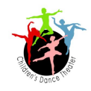
CDT Performing Arts Scholarship Application $1,5000.00
Please submit the completed application, and required attachments by May 1, 2024.
Name:________________________________________ Date of Application__________ Mailing Address: _____________________________________________________ _____________________________________________________
_____________________________________________________
Telephone Number: _______________________ How long lived in County: _______ Name of High School or Home School Program: _______________________________ Date of High School Graduation: ______________________ GPA: ____________ Parent Name(s): _________________________________________________________ College or University you are attending in fall of 2024___________________________ Major and Minor_________________________________________________________ School activities participated in: ____________________________________________ _______________________________________________________________________ Student Offices held: _____________________________________________________ Other Activities or Volunteer positions held: ___________________________________ _______________________________________________________________________ _______________________________________________________________________ Area of focus in the Performing Arts: ________________________________________ Classes or Workshops you have taken related to the arts: _________________________ _______________________________________________________________________ Performances or other rolls that you have been in: ______________________________ _______________________________________________________________________
Betty Clough, CDT
PO BOX 491, Oroville, WA 98844

